Name of Student : Raghav Mahesh Sarda PRN: 25070122235
Subject: Programming with Java Semester: III
ASSIGNMENT No : 9 Year: AY 2026-27
TITLE : Final Keyword In Java

Problem Statement
Write a Java program to demonstrate the use of the final keyword with variables, methods, and classes.

Learning Objectives
To implement the final keyword with variables, methods, and classes.

Program:
BankAccount.java
// Assignment 9 - Exercise 1: Bank Account using final variable
import java.util.*;
public class BankAccount
{
final int accNo; // Final variable declaration
String name;
double balance;

BankAccount(int a, String n, double b) // Constructor
{
accNo=a; // Initializing final variable
name=n;
balance=b;
}
void display() // Display method
{
System.out.println("\n-- Account Details --");
System.out.println("Account No (Final): " + accNo);
System.out.println("Holder Name: " + name);
System.out.println("Balance: $" + balance);
}

public static void main(String args[]) // Main Method
{
Scanner sc = new Scanner(System.in);
System.out.print("Enter Account Number: ");
int an = sc.nextInt();
sc.nextLine(); // Consuming newline

System.out.print("Enter Account Holder Name: ");
String hn = sc.nextLine();

System.out.print("Enter Opening Balance: ");
double bl = sc.nextDouble();

BankAccount acc = new BankAccount(an, hn, bl); // Creating object
acc.display(); // Displaying account details

// acc.accNo = 12345; // Will give an error, as we cannot assign a value to the final variable
sc.close();
}
}

LibraryBookManagementSystem.java
// Assignment 9 - Exercise 2: Library Book Management using final class and method
import java.util.*;
final class LibraryBook // Final class (cannot be inherited)
{
final String isbn; // Final variable
String title;
String author;
double price;
LibraryBook(String i, String t, String a, double p) // Constructor
{
isbn=i;
title=t;
author=a;
price=p;
}
final void display() // Final method (cannot be overridden)
{
System.out.println("\n--- Book Details ---");
System.out.println("ISBN: " + isbn);
System.out.println("Title: " + title);
System.out.println("Author: " + author);
System.out.println("Price: $" + price);
}
}

public class LibraryBookManagementSystem
{
public static void main(String args[]) // Main method
{
Scanner sc = new Scanner(System.in);
System.out.print("Enter Book ISBN: ");
String i = sc.nextLine();
System.out.print("Enter Book Title: ");
String t = sc.nextLine();
System.out.print("Enter Book Author: ");
String a = sc.nextLine();
System.out.print("Enter Book Price: ");
double p = sc.nextDouble();

LibraryBook book = new LibraryBook(i, t, a, p); // Creating final class object
book.display(); // Displaying book details

sc.close(); // Closing scanner
}
}

Output:
BankAccount.java
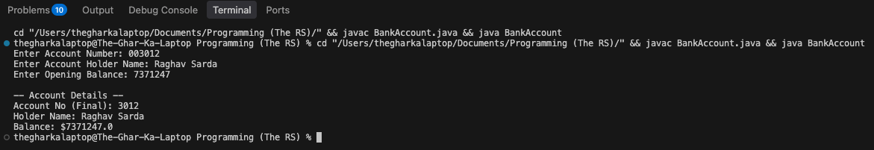

LibraryBookManagementSystem.java
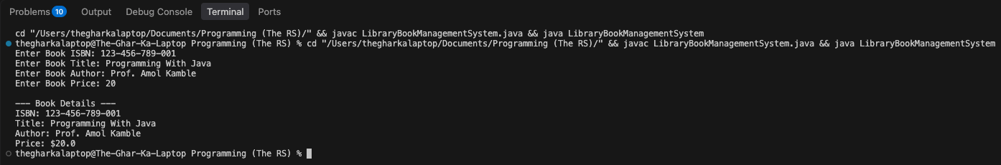

Conclusion:
In this assignment, the final keyword was successfully implemented to restrict modification across variables, methods, and classes. It ensured constant data assignments like account numbers and ISBNs, while applying it to methods and classes, and prevented unintended method overriding and class inheritance.

